Implement advanced monitoring and alerting using cloud-native tools and services.

Ebuka Obiakor – 13th March 2024

## EXAMPLE – SETTING UP CLOUDWATCH connected to SNS

CloudWatch is primarily a **monitoring service.** It collects and stores system-level metrics, logs, and events from various AWS resources.

Figure 1: CloudWatch process flow; source : SkillCurb

Figure 2: Services that can be monitored with CloudWatch; Source: SkillCurb

## DEMO

[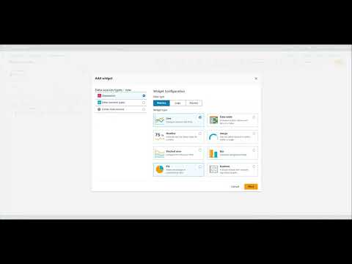](https://www.youtube.com/embed/KjPI9XdvyoI?feature=oembed)

Figure 3: Using CloudWatch to set up metrics and monitoring (clickable video link ↑).

## APPENDIX

***Services that can be used for monitoring and alerting using AWS cloud include:***

1. **Amazon CloudWatch:**
   * **Purpose:** CloudWatch is primarily a **monitoring service.** It collects and stores system-level metrics, logs, and events from various AWS resources.
   * **Key Features**:
     + **Metrics Monitoring**: CloudWatch allows you to monitor performance metrics (e.g., CPU utilization, network traffic) of your instances and other resources.
     + **Log Aggregation**: It serves as a central location for storing logs from applications, services, and AWS resources.
     + **Event Response**: CloudWatch can trigger actions based on live events (e.g., executing a Lambda function when an instance terminates).
   * **Use Cases**: Useful for monitoring resource health, analyzing logs, and setting up alarms based on thresholds.
2. **Amazon Simple Notification Service (SNS)**:
   * **Purpose**: SNS is a fully managed messaging service that enables you to send notifications, alerts, and messages to a variety of endpoints (such as email, SMS, HTTP, Lambda, and more).
   * **Key Features**:
     + **Publish-Subscribe Model**: SNS follows a publish-subscribe pattern, where publishers send messages to topics, and subscribers receive those messages.
     + **Flexible Endpoints**: You can choose various endpoints to receive notifications based on your requirements.
     + **Fanout**: SNS allows broadcasting messages to multiple subscribers.
   * **Use Cases**: Ideal for sending notifications, event-driven architectures, and decoupling components in your applications.
3. **AWS CloudTrail**:
   * **Purpose**: CloudTrail is an audit trail service that records API calls made within your AWS account. It captures details of requests, including the user, source IP, timestamp, and request parameters.
   * **Key Features**:
     + **API Activity Tracking**: CloudTrail monitors and logs API calls across various AWS services.
     + **Security and Compliance**: It helps with security analysis, resource change tracking, and compliance auditing.
     + **Integration with Other Services**: CloudTrail logs can be delivered to Amazon S3 or analyzed using services like Amazon Athena or Amazon Elasticsearch.
   * **Use Cases**: Useful for security monitoring, compliance, and troubleshooting.
4. **AWS Trusted Advisor**:
   * **Purpose**: Trusted Advisor provides recommendations to optimize your AWS resources, improve security, and reduce costs. It analyzes your account based on best practices and AWS guidelines.
   * **Key Features**:
     + **Cost Optimization**: Trusted Advisor identifies cost-saving opportunities, such as unused resources or overprovisioned instances.
     + **Performance and Security Checks**: It assesses security settings, performance bottlenecks, and fault tolerance.
     + **Personalized Recommendations**: Trusted Advisor tailors recommendations to your specific AWS usage.
   * **Use Cases**: Valuable for maintaining a healthy AWS environment, ensuring best practices, and avoiding common pitfalls.

In summary:

* **CloudWatch** is for general monitoring service for resources and environment.
* **SNS** is for sending notifications.
* **CloudTrail** is for monitoring API calls and auditing.
* **Trusted Advisor** provides personalized recommendations for optimizing your AWS resources.

**Resources**

[What is Amazon CloudWatch? - Amazon CloudWatch](https://docs.aws.amazon.com/AmazonCloudWatch/latest/monitoring/WhatIsCloudWatch.html)

<https://www.youtube.com/watch?v=Yxl7e88cTAQ&ab_channel=TinyTechnicalTutorials>

<https://youtu.be/lHWrAAzoxJA?si=u1rhvf8oTb6R2s7C>

<https://youtu.be/_Tqce6pGb44?si=-gReyZvjGgrQWyEv>